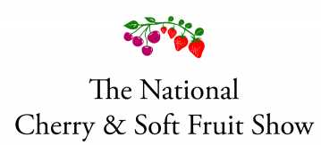
Return to: Catherine Joules
Hope Farm, West Brabourne, Ashford, Kent TN25 5NB
Tel 07976 465035
Email: secretary@ncsfs.co.uk

Please note: multiple entries in the same class should be listed as separate entries.

Class No. | Description
Name:
Address (for sending packaging):
Contact no.:
Email address:

If you would like a donation towards the running of the show, it would be very welcome.
Our bank details are:
Account name: National Cherry & Soft Fruit Show Account
Sort code: 606008
Account no: 00050474

